**Back to the DOM & More Browser APIs**

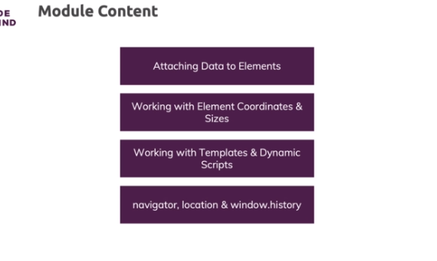

**Using "dataset" (data-* Attributes)**

* the data- attribute in general is a special attribute you can add to your own elements to attach any kind of data to them
* so you could add data-id, data- whatever, data- whatever attribute or value you want to append or you want to store on one of your DOM nodes

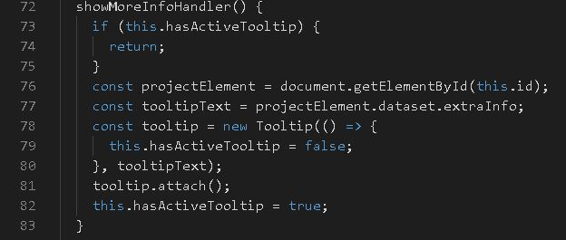

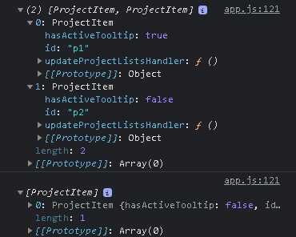

**Getting Element Box Dimensions**

* you can also use something like rem which is dynamically calculated,
* you can use percentages, you can use media queries to use dynamic different sizes
* can indeed get coordinates and so on

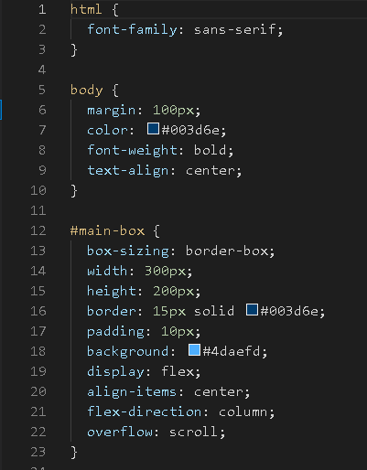

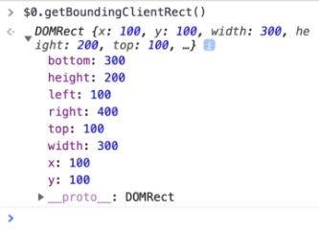

**Working with Element Sizes & Positions**

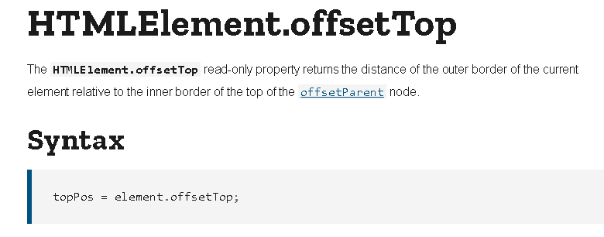

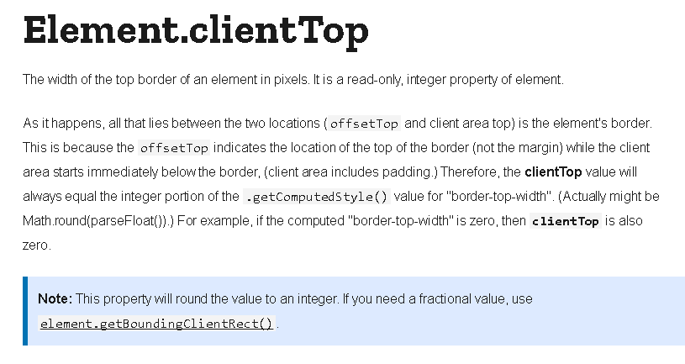

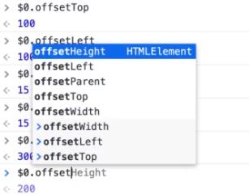

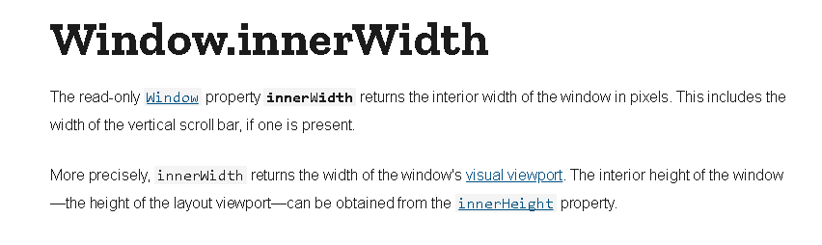

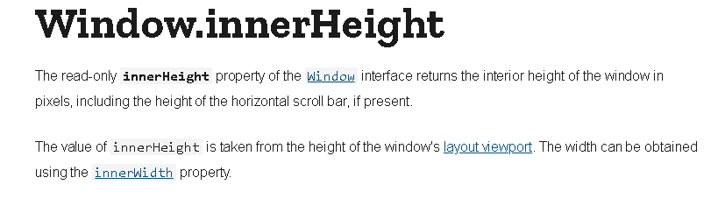

**The DOM & Prototypes**

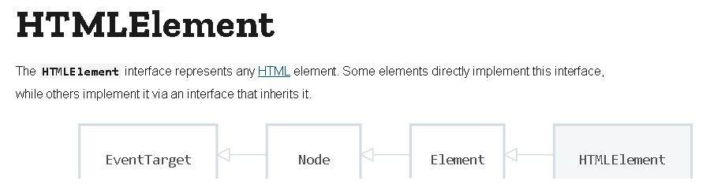

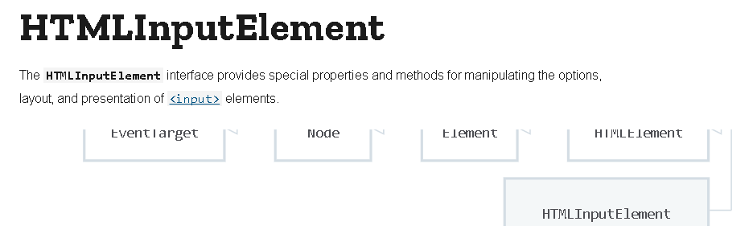

**Positioning the Tooltip**

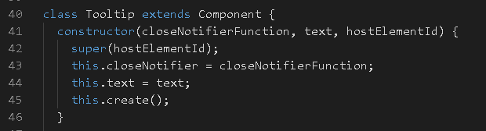

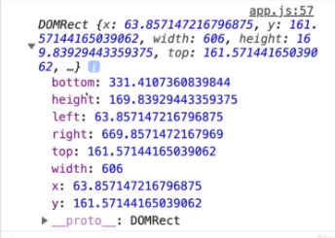

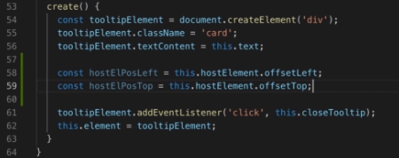

**Handling Scrolling**

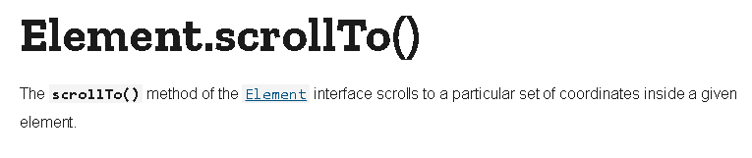

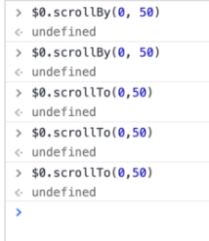

https://paper-attachments.dropbox.com/s_CCAD4D561BCCBD03B2E0B5CB8F37527215F3B27EDD0C1D6CA0B04DCD38A44A05_1632585938999_screenshot-www.udemy.com-2021-09-25-21-35-24-902.png

**Working with <template> Tags**

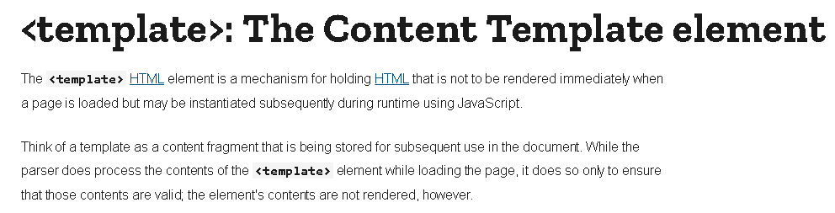

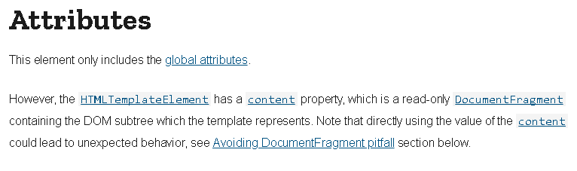

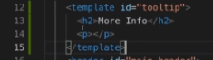

https://paper-attachments.dropbox.com/s_CCAD4D561BCCBD03B2E0B5CB8F37527215F3B27EDD0C1D6CA0B04DCD38A44A05_1632586175315_screenshot-www.udemy.com-2021-09-25-21-38-55-654.png

**Loading Scripts Dynamically**

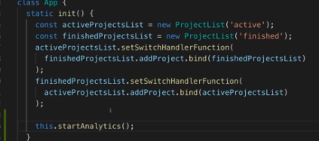

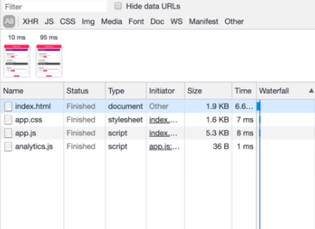

**Setting Timers & Intervals**

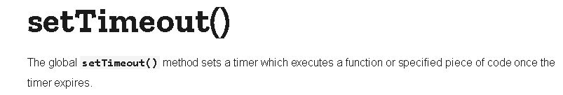

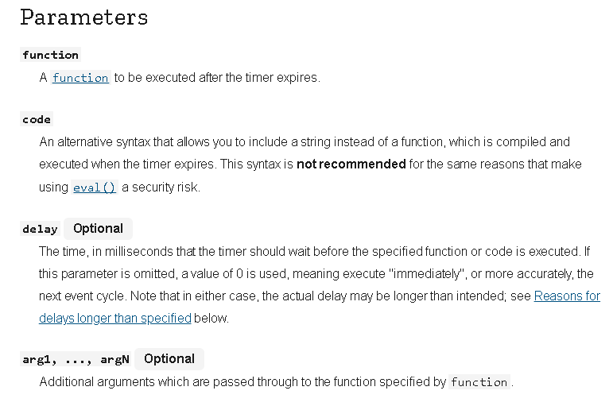

* setTimeout takes two arguments
* the first argument is a function which should be executed when the timer expired
* this can be an anonymous function, both an arrow function or a normal function
* The second argument then is the amount of time you want to give the timer
* the browser manages the timer and also just registers that this function should be called when the timer expired
* then once the browser sees that the timer expired, it will come back to your script and execute this function for you.
* a third argument here and that would be an array of arguments you might want to pass in to that function when it executes. This function here

https://paper-attachments.dropbox.com/s_CCAD4D561BCCBD03B2E0B5CB8F37527215F3B27EDD0C1D6CA0B04DCD38A44A05_1632586773351_screenshot-www.udemy.com-2021-09-25-21-49-29-053.png

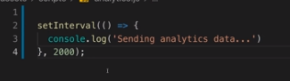

**The "location" and "history" Objects**

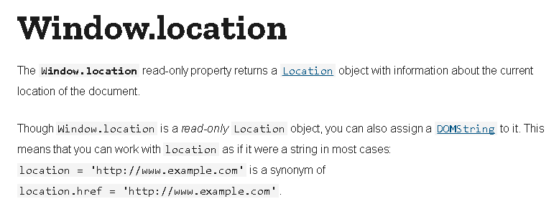

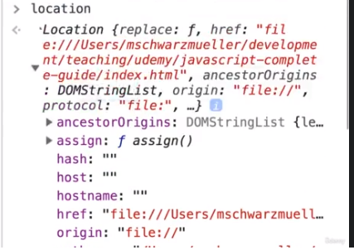

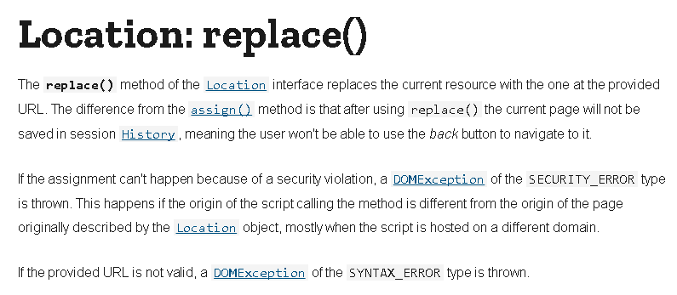

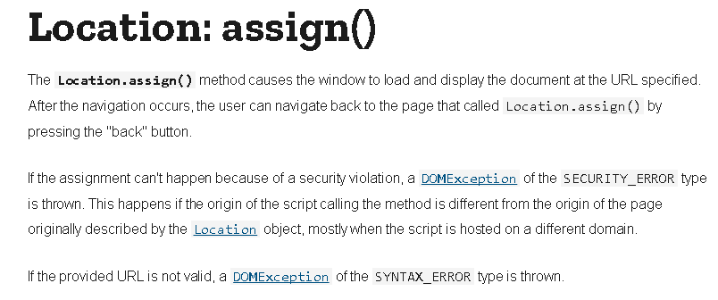

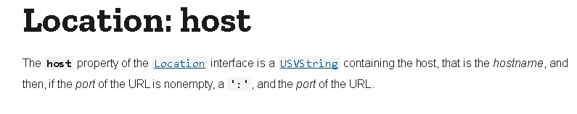

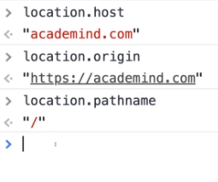

**The "navigator" Object**

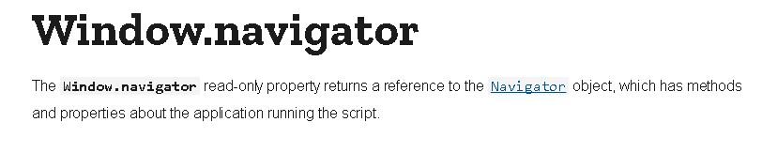

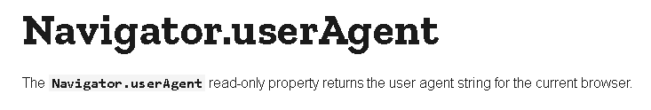

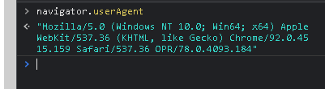

**Working with Dates**

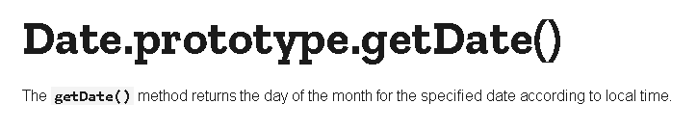

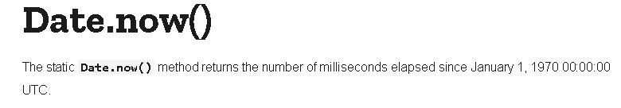

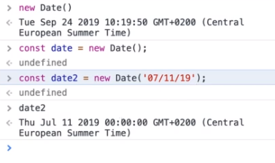

**The "Error" Object & Constructor Function**



